**<Bootstrapping for Fuzzy Mediation, Moderated-Mediation Analysis>**

When describing human behavior, social scientists and behavioral scientists hold that when people are exposed to particular stimuli, they do not instantly react but rather do so through internal organic body.  We have been curious in the process by which one phenomenon influences another because of this. By adding a third variable, they attempted to investigate the causal relationship between the independent and dependent variables and better comprehend their relationship, and it was discovered that the mediator and moderator components of this variable are separated.

A mediator variable is a variable that logically intervenes between independent and dependent variables in the causal relationship and is required to explain why or how.

For instance, client satisfaction will increase as a result of a company's satisfied products. In other words, consumers who are happy with the product will also be satisfied with the company; on the other hand, customers who are unhappy with the product will typically be less satisfied. The variable that describes how this relationship impacts is the mediator variable in this instance where there is a static correlation between product satisfaction and customer satisfaction. In this relationship, it may be inferred that as consumer trust in the the product's manufacturer increases, so does the positive correlation between product satisfaction and customer satisfaction. The purpose of the mediation effect study is to identify a variable that may more effectively explain the relationship that exists in the middle by determining if there is a meaningful influence between these two variables. A moderator variable is a variable that influences the amount and direction of the relationship between independent and dependent variables. The purpose of a moderation effect study is to determine how moderator factors affect the intensity or direction of the relationship between independent and dependent variables. The purpose is to determine if, and under what circumstances, when, or from whom, the relationship between the two variables is weaker or stronger. Researchers in several fields have researched this mediation impact and moderation effect. [] Additionally, studies have been conducted in the past to confirm the relevance of combining mediation effects and moderation effects for qualitative comprehension between variables. [] One example of this is the moderated mediation effect, which will be discussed in this article. The term "moderated mediation effect," was first introduced in 1984 by James & Bret [], refers to the regulation of a particular variable or the intensity of the mediation effect. In other words, the mediation effect is either reinforced or diminished as the value of the moderator variable increases (Jame & Bret, 1984). In Fig. 1, the mediation effect, moderation effect, and moderated mediation effect are represented as a simple model.

The regression-based assessment techniques developed by Sobel (1982), Baron and Kenny (1986), and Aroian and Goodman test methods have all been extensively utilized in recent thesis to conduct mediation analyses. However, the examination of the mediation effect using Baron and Kenny (1986) only establishes if the mediation effect exists or not; it does not establish its statistical significance. Furthermore, in the analytical sequence and judgment process in the case of statistical significance of the mediation effect, the other Sobel, Aroian, and Goodman methodes are not simple , and these methodes have weak statistical power and do not account for measurement mistakes in the study model. The method employing bootstrap has lately been utilized in several studies as a way to address this since it is thought to have limitations in terms of confirming the mediation model and that it is not accurate.

 In the meantime, the study of these mediation models was carried out using "precise numbers." However, there are certain statistics that are difficult to convey with precise numbers in reality because they contain ambiguous phrasing. It is simple to communicate language connotations like "some" and "moderate," but it might be challenging to work with precise numerical data. Particularly in the area of social science that deals with psychology, we often come across such ambiguous facts, and in trying to describe them in exact figures, we not only risk losing knowledge but also run into issues. It is true that a precise number cannot accurately capture a person's mental aspect, for instance, when a person's degree of stress is assessed as a variable. Additionally, even though this is stated numerically, each person's assessment scale is unique, so even if the data value is the same, it could really be a different value. As a result, if it is coded as it is, information loss is unavoidable. As a result, it makes sense to describe it as a soft number, like the fuzzy number that Zadeh initially proposed.

 Yoon carried out a mediation study based on fuzzy theory in 2020 []. However, there has been no research done on the bootstrap paper using fuzzy mediation and fuzzy moderated-mediation. Bootstrap has been prevalently cited as a method for verifying the mediating effect. However, the Baron & Kenny method, an inaccurate statistical method with errors in statistical inference, and the sampling distribution, which shows the biased distribution with the assumption that the sampling distribution forms the normal distribution, are the alternatives to Sobel’s method, which encounters the criticism for not being able to verify statistically significant mediating effects. However, it is a beneficial method with strengths in that it does not require any assumptions for the variable and sampling distribution. In example, the bootstrap method, which requires millions of resampling operations, has been more popular lately as access has become simpler and computer speed has increased through the statistical software like R and Python. Therefore, in this study, we suggest utilizing the bootstrapping method to examine the fuzzy mediation model and the fuzzy moderated mediation model.

**2. Fuzzy Mediation and Moderated-Mediation Analysis**

**2.1 기존의 매개효과 검정 방법**

**2.1.1 Baron & Kenny**

Baron & Kenny’s (1986) research has made a clear definition of mediating effect and controlling factors and explained the logic of verification on mediating effect readily intelligibly and intuitively. It is the most widely cited method in the papers as a testing method of the mediating effect by verifying how the mediating effect can be proven.

The method has recently encountered criticisms due to a bevy of problems. When estimating the size of the mediating effect, the conclusion on the mediating effect has been made indirectly by verifying with different figures in order not by verifying from the statistical reasoning to determine if the size has a significant meaning. An error can occur at in anytime, especially when examining a hypothesis. The probability of an error is inevitably getting higher as the number of hypotheses to be proven increases simultaneously. Hence, it has turned out that the reliability of the testing is weak due to excessive errors that occurred from the sequential testing of multiple hypotheses (e.g., Fritz & MacKinnon, 2007; Hayes & Schaarkow, 2013). In addition, it is widely known that Baron & Kenny’s testing method analyzes the mediating effect based on the assumption that the effect of independent variables on the dependent variables should be statistically significant. However, it is not valid. The verification method of the mediating effect is under the criticism that it is not an accurate statistical method rather than it is not statistically close.

**2.1.2 Sobel Test**

The core problem of Baron & Kenny’s verification method occurs indirectly in the verification process of mediating effect. Sobel’s (1982) method can be considered an advanced approach in that the method calculates the magnitude of the effect directly. Researchers frequently cite the Sobel test since the method can be utilized comparatively simply than other methods in verifying the mediating effect. However, it is found that there are defects in Sobel’s verification method. When verifying the significance of the mediating effect with Sobel’s testing method, the assumption is that the sample distribution of the value forms the normal distribution. Unlike the assumption, however, the sampling distribution used widely by most researchers in mediating effect verification is mostly deflective, not showing the normal distribution (Bollen & Stein, 1990; Shrout & Bolger, 2002). Therefore, it can be deduced that Sobel’s method has limitation in telling the statistical significance of mediating effect (Fritz & MacKinnon, 2007; Hayes & Scharkow, 2013).

**2.2 Bootstrapping**

Generally, the confidence interval of the mediating effect has been calculated based on the assumption that the sampling distribution follows the normal distribution or a t distribution. However, the cases where the extracted samples do not follow a normal or t distribution are found. If the confidence interval is calculated with a normal distribution or a t distribution when the sampling distributions are not symmetrical, it can provide an approximation of the correct confidence interval. However, it cannot always provide a reliable approximate value as always. As an alternative to the weakness of the method, the bootstrapping method has recently become pervasive for researchers.

The bootstrapping method is a statistical method that estimates the sample distribution based on the empirical distribution utilizing sample data while the sample distribution is not informed. Namely, given the fact that the method can calculate the approximate standard error, confidence interval, and significance probability of the estimated sample distribution by repeatedly projecting after extracting and restoring the same-sized sample randomly without making any assumptions on the distribution of variables or sample distribution (Figure 0)

Two methods have been suggested for verifying the mediating effect with bootstrapping. First, one is to determine whether zero is included in the confidence interval of the re-extracted sample distribution, and the second is to identify the effect with the significant probability of total indirect effect through the decomposition of testing mediating method. The specific methods that calculate the confidence interval can be categorized into Percentile and Bias-corrected.

The method to examine the mediating effect by utilizing the bootstrapping method has been introduced by several scholars since the 1990s (Bolen & Stein, 1990). Despite the strengths the method has, the reason why the bootstrapping method has not been widely accepted was derived from the difficulty in executing a considerable amount of calculation without using a computer, and there were inevitable limitations in application due to its complexity in programming. However, along with the significant advancement in computer development and the simplified procedures in using bootstrapping through the various statistic packages, the utilization ratio of the method is getting higher in different academic fields. Therefore, in this paper, the statistical significance of the fuzzy mediation model was explained using bootstrap.

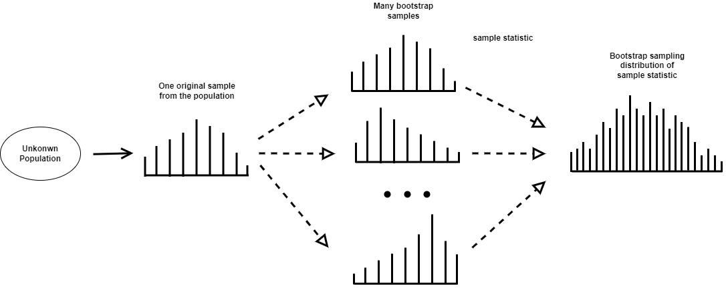

**2.2.1 Percentile bootstrap**

When the magnitude of the influence of the independent variable on the parameter is set as a, and the magnitude of the effect of the parameter on the dependent variable, controlling the influence of the independent variable, is set as b, the indirect effect can be defined as ab. Among the reasoning methods that do not require assumptions on the sampling distribution of ab that refers to the magnitude of the indirect effect, there is a typical method that test the indirect effect by utilizing the confidence interval of a bootstrap. One of the procedures to set the confidence interval (95%) by the percentile bootstrap method is as follows (Shrout & Bolger 2002). All procedures are automatically carried out in PROCESS macro, a computer program developed by Hayes.

Reinforcement is extracted from the original sample with sample size N extracted from the population, and a bootstrap sample with the same size N as the original sample is extracted.

1. Using the bootstrap sample obtained in step 1, estimate the statistics of indirect effects in the resampling.
2. Repeat steps 1 and 2 k times to generate k bootstrap samples and estimate and store k indirect effects using them.
3. Sort the k indirect effect estimates from lowest to highest.
4. In the case of using a 95% confidence interval, the lower limit is defined as the statistic value corresponding to the 0.5th (100-95)th percentile of the distribution of the previously obtained statistic value. The upper bound is defined as the statistic corresponding to the [100-0.5 (100-95)]th percentile from the distribution of k statistics arranged in ascending order. The lower and upper bound values are determined as the endpoints of the 95% confidence interval.

If 0 is not included in this 95% confidence interval, the indirect effect is said to be statistically significant.

**2.2.2 Bias-corrected bootstrap**

A bias-corrected bootstrap compliments the potential bias in percentile bootstrap confidence intervals was suggested by Efron and Tibshirani (1986). The Bias-corrected approach shares the same grounds with the percentile confidence interval. However, it is different from the percentile bootstrap confidence interval in that the bias constant is calculated by utilizing the ratio of the point numbers more minor than the point estimate value of the indirect effect of the original sample among the k indirect effect estimates calculated from the k bootstrap samples. It is a revised confidence interval that equals the error rates of both ends of the percentile bootstrap confidence interval. It determines the upper and lower bounds of the confidence interval by closely reflecting the asymmetry of the bootstrap estimate distribution. Therefore, when the sampling distribution of the estimate is not symmetrical, the Bias-corrected method is more suitable for obtaining more accurate results. However, recently, several reports have mentioned that bias-corrected bootstrapping may not be a proper testing method since it causes type I error despite its high proving capability (Biesanz et al.,2010, Hayes & Scharkow, 2013, Falk & Biesanz, 2015, Tofighi & Kelly, 2020).